NAME: RAJA RAYYAN AMEER
REG. NO.: 23-CP-25
SECTION: ALPHA
SUBJECT: ML&AI
DEPARTMENT: COMPUTER ENGINEERING
TEACHER: SIR SHAHID
LAB 12:
Task 1: Feature Normalization
Task 2: The Covariance Matrix
Task 3: Eigen Decomposition
Task 4: Projection Plotting
Task 5: PCA for Supervised Learning
Program:
import numpy as np
import pandas as pd
import matplotlib.pyplot as plt
from sklearn.linear_model import LinearRegression
from sklearn.model_selection import train_test_split
from sklearn.metrics import mean_squared_error

heart_df = pd.read_csv("Lab 12 Heart Disease UCI.csv")
student_df = pd.read_csv("Lab 12 Student Data.csv")

# Keep only numeric data
heart_df = heart_df.select_dtypes(include=[np.number]).dropna()
student_df = student_df.select_dtypes(include=[np.number]).dropna()

# TASK 1 – FEATURE NORMALIZATION
print("\n TASK 1: NORMALIZATION ")

def normalize(X):
mu = np.mean(X, axis=0)
sigma = np.std(X, axis=0)
X_norm = (X - mu) / sigma
return X_norm, mu, sigma

X_heart = heart_df.values
X_norm, mu, sigma = normalize(X_heart)

print("Mean:\n", mu)
print("Std Dev:\n", sigma)
print("Normalized Sample:\n", X_norm[:5])

# TASK 2 – COVARIANCE MATRIX
print("\n TASK 2: COVARIANCE MATRIX ")

m = X_norm.shape[0]

cov_matrix = (X_norm.T @ X_norm) / m

print("Covariance (Matrix):\n", cov_matrix)

# TASK 3 – PCA (EIGEN DECOMPOSITION)
print("\n TASK 3: PCA ")

eigenvalues, eigenvectors = np.linalg.eig(cov_matrix)

# Sort descending
idx = np.argsort(eigenvalues)[::-1]
eigenvalues = eigenvalues[idx]
eigenvectors = eigenvectors[:, idx]

# Reduce dimensions (k=2)
k = 2
U_reduced = eigenvectors[:, :k]

# Project data
Z = X_norm @ U_reduced

print("Top Eigenvalues:\n", eigenvalues[:k])
print("Projected Data Sample:\n", Z[:5])

# TASK 4 – PROJECTION PLOTTING
print("\n TASK 4: PLOTTING ")

# Create synthetic 3D planar data
np.random.seed(0)
X3D = np.random.rand(200, 2)
Z_plane = X3D[:, 0] + X3D[:, 1]
X3D = np.column_stack((X3D, Z_plane))

# Normalize
X3D_norm, _, _ = normalize(X3D)

# PCA to 2D
cov_3d = (X3D_norm.T @ X3D_norm) / len(X3D_norm)
eigval_3d, eigvec_3d = np.linalg.eig(cov_3d)
idx3d = np.argsort(eigval_3d)[::-1]
U2 = eigvec_3d[:, idx3d[:2]]

Z2D = X3D_norm @ U2

# Plot
fig = plt.figure(figsize=(10,4))

# 3D plot
ax = fig.add_subplot(121, projection='3d')
ax.scatter(X3D_norm[:,0], X3D_norm[:,1], X3D_norm[:,2])
ax.set_title("Original 3D Data")

# 2D projection
plt.subplot(122)
plt.scatter(Z2D[:,0], Z2D[:,1])
plt.title("Projected 2D Data")

plt.show()

# TASK 5 – PCA + LINEAR REGRESSION
print("\n TASK 5: PCA + REGRESSION ")

# Use student dataset
X = student_df.iloc[:, :-1].values
y = student_df.iloc[:, -1].values

# Train-test split
X_train, X_val, y_train, y_val = train_test_split(X, y, test_size=0.2)

# --- WITHOUT PCA ---
model = LinearRegression()
model.fit(X_train, y_train)

train_pred = model.predict(X_train)
val_pred = model.predict(X_val)

train_loss = mean_squared_error(y_train, train_pred)
val_loss = mean_squared_error(y_val, val_pred)

print("Without PCA, Train Loss: ", train_loss)
print("Without PCA, Val Loss: ", val_loss)

# --- WITH PCA ---
X_norm, _, _ = normalize(X)

cov = (X_norm.T @ X_norm) / len(X_norm)
eigval, eigvec = np.linalg.eig(cov)

idx = np.argsort(eigval)[::-1]
U_k = eigvec[:, idx[:2]]

Z = X_norm @ U_k

Z_train, Z_val, y_train, y_val = train_test_split(Z, y, test_size=0.2)

model_pca = LinearRegression()
model_pca.fit(Z_train, y_train)

train_pred_pca = model_pca.predict(Z_train)
val_pred_pca = model_pca.predict(Z_val)

train_loss_pca = mean_squared_error(y_train, train_pred_pca)
val_loss_pca = mean_squared_error(y_val, val_pred_pca)

print("With PCA, Train Loss: ", train_loss_pca)
print("With PCA, Val Loss: ", val_loss_pca)

# BAR GRAPH COMPARISON

labels = ['Train Loss', 'Validation Loss']

without_pca = [train_loss, val_loss]
with_pca = [train_loss_pca, val_loss_pca]

x = np.arange(len(labels))
width = 0.35

plt.figure()
plt.bar(x - width/2, without_pca, width, label='Without PCA')
plt.bar(x + width/2, with_pca, width, label='With PCA')

plt.xticks(x, labels)
plt.ylabel("Loss")
plt.title("Loss Comparison (With vs Without PCA)")
plt.legend()
plt.show()
Output:
TASK 1: NORMALIZATION
Mean:
[165.46428571 54.63311688 131.68181818 241.48376623 148.7987013
1.04675325 0.67857143 0.9512987 ]
Std Dev:
[121.73076273 8.96847694 17.65311662 62.10927004 23.1196436
1.15388496 0.93485635 1.22774934]
Normalized Sample:
[[-1.3510495 0.93292129 0.75443799 -0.1365942 0.05196009 1.08611066
-0.72585636 -0.77483137]
[-1.34283465 1.37892791 1.60414631 0.71674057 -1.76467691 0.39280064
2.48319281 0.85416564]
[-1.3346198 1.37892791 -0.66174254 -0.20099683 -0.85635841 1.34610192
1.41350975 0.03966713]
[-1.32640495 -1.96612167 -0.09527033 0.13711695 1.65233078 2.12607568
-0.72585636 -0.77483137]
[-1.3181901 -1.52011506 -0.09527033 -0.60351323 1.00353185 0.30613689
-0.72585636 -0.77483137]]

TASK 2: COVARIANCE MATRIX
Covariance (Matrix):
[[ 1. 0.06595118 -0.00917175 -0.43696284 -0.20428795 -0.09100648
0.06835722 0.04531543]
[ 0.06595118 1. 0.29001564 0.10655895 -0.39269492 0.19244201
0.37201787 0.21628135]
[-0.00917175 0.29001564 1. 0.10746112 -0.05632804 0.197292
0.09492494 0.14084811]
[-0.43696284 0.10655895 0.10746112 1. 0.09152762 0.04872982
0.05160589 0.03181653]
[-0.20428795 -0.39269492 -0.05632804 0.09152762 1. -0.33275167
-0.26527505 -0.40834668]
[-0.09100648 0.19244201 0.197292 0.04872982 -0.33275167 1.
0.28030112 0.48907349]
[ 0.06835722 0.37201787 0.09492494 0.05160589 -0.26527505 0.28030112
1. 0.51533778]
[ 0.04531543 0.21628135 0.14084811 0.03181653 -0.40834668 0.48907349
0.51533778 1. ]]

TASK 3: PCA
Top Eigenvalues:
[2.48961276 1.52103162]
Projected Data Sample:
[[ 0.16668851 -1.15230113]
[ 3.25883 -1.42201393]
[ 1.85860153 -0.67531251]
[-1.410553 -1.52273659]
[-1.74015838 -0.65463561]]

TASK 4: PLOTTING
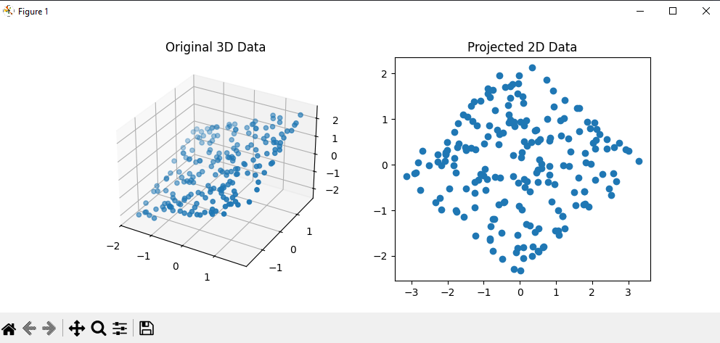
TASK 5: PCA + REGRESSION
Without PCA, Train Loss: 3.326426592382691
Without PCA, Val Loss: 3.8432881010739823
With PCA, Train Loss: 10.7298623254715
With PCA, Val Loss: 8.473172930973657
